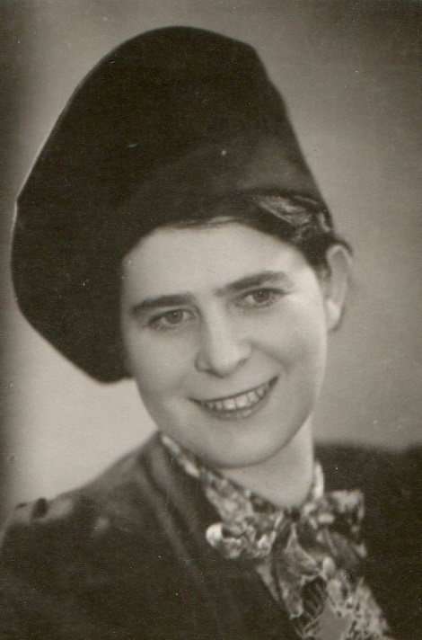
Dear Madam, Dear Sir,

The representation of Pilsen Region in Brussels cordially invites you to a festive opening of the exhibition

Claire Beck - Loos, the Witness to an Era

on Thursday 21 June from 7.00 p.m. at the Pilsen House in Brussels, Place de Jamblinne de Meux 31.

You are kindly requested to confirm your attendance at zbynek.prokop@pilsenregion.eu

